Maths Home learning task- Friday 22nd February 2024
Can you create add and subtract number sentences linked to fact families?
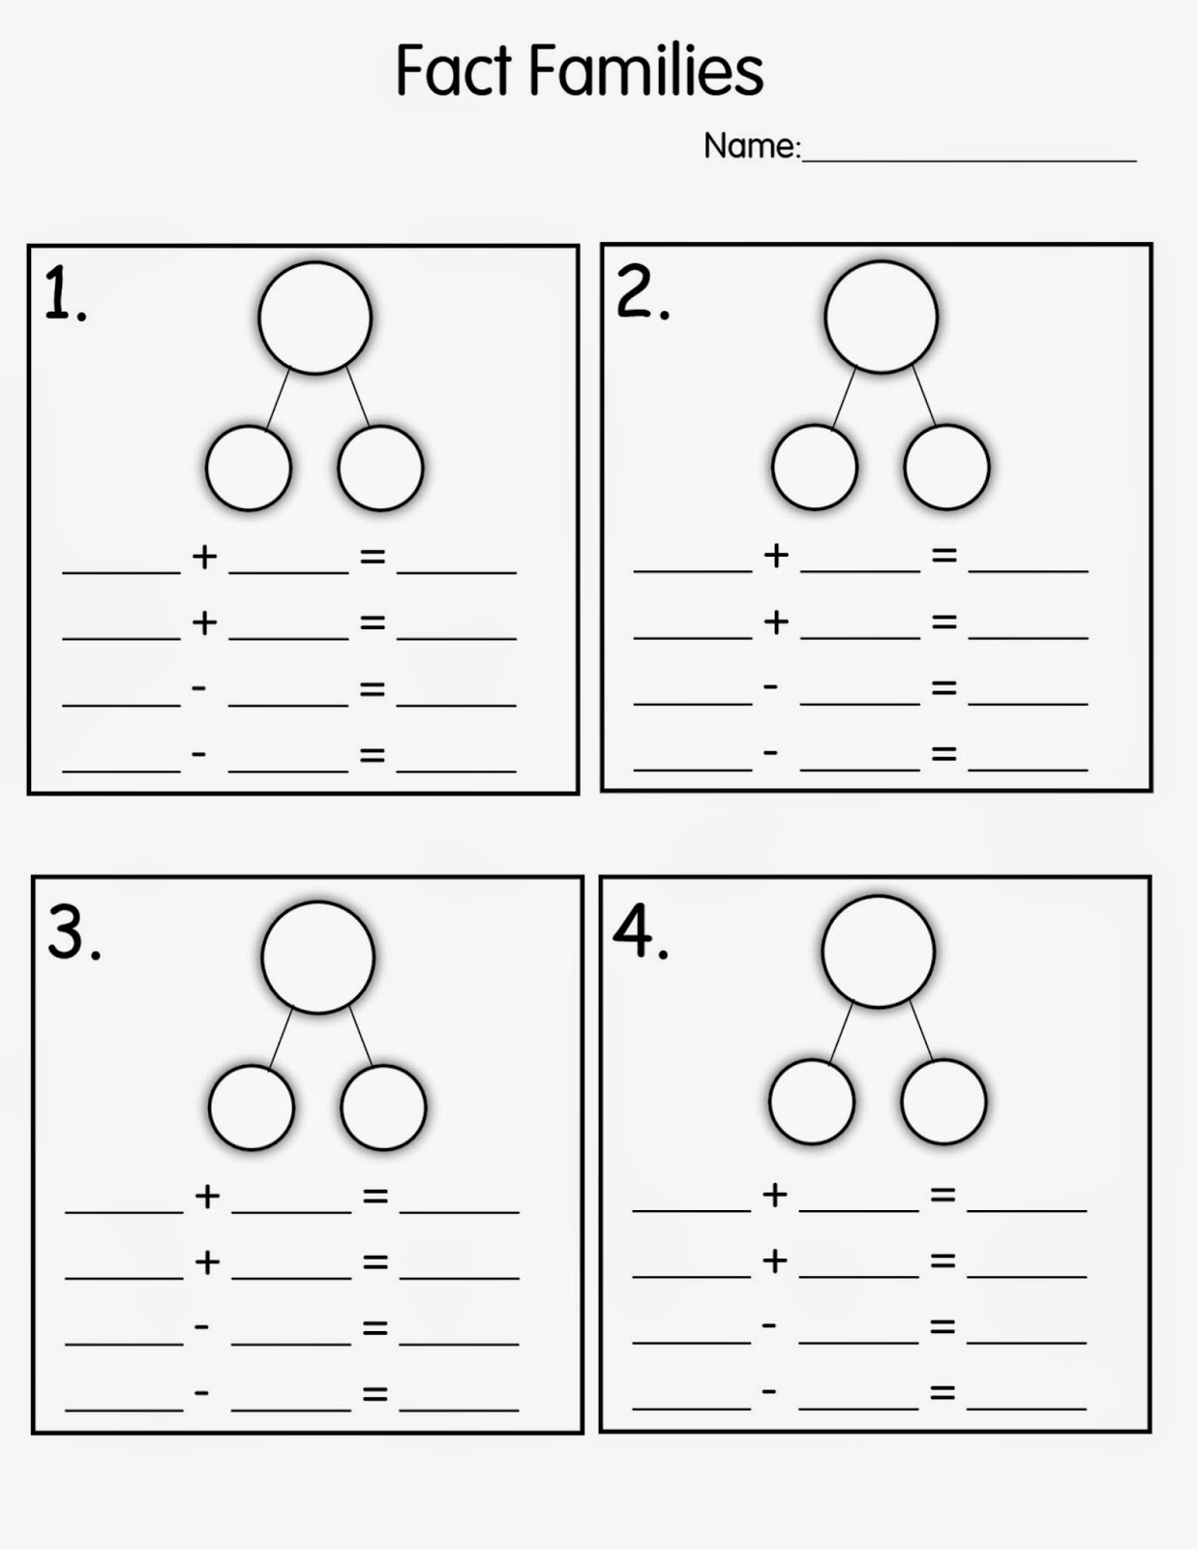
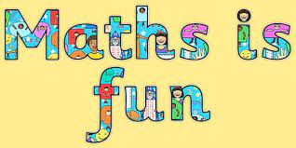
4
10
6
6
10
10
10
6
6
10
3
4
8
2
9
13
12
11
10
4

