Some apps and websites that will help your child with their reading and phonics:

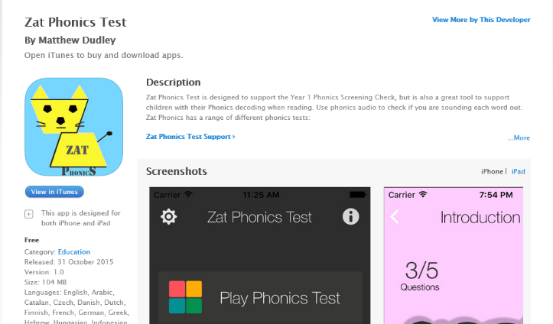

Mr Thorne has a website and a range of apps you can download for differing stages of development.

- http://www.phonicsplay.co.uk/freeIndex.htm choose phase 5

The web site below is the one we use in school each day.
http://www.oxfordphonicschecksupport.co.uk/login?
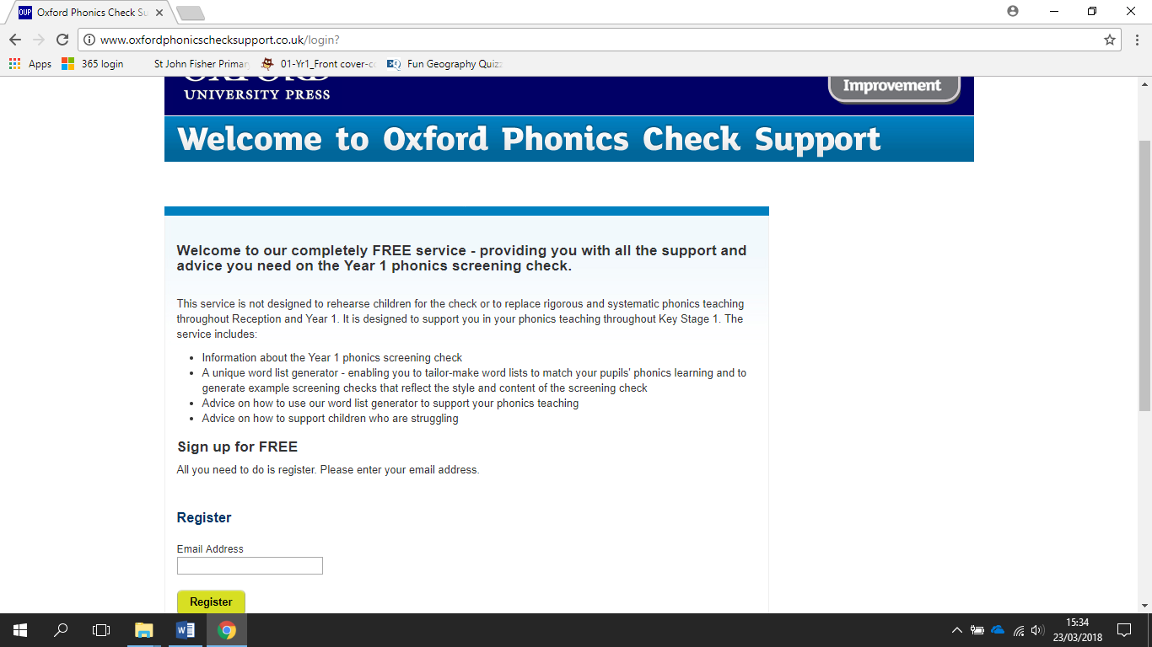

Chose register and add an email address
Once registered, sign in as a returning visitor, you’ll get the following page
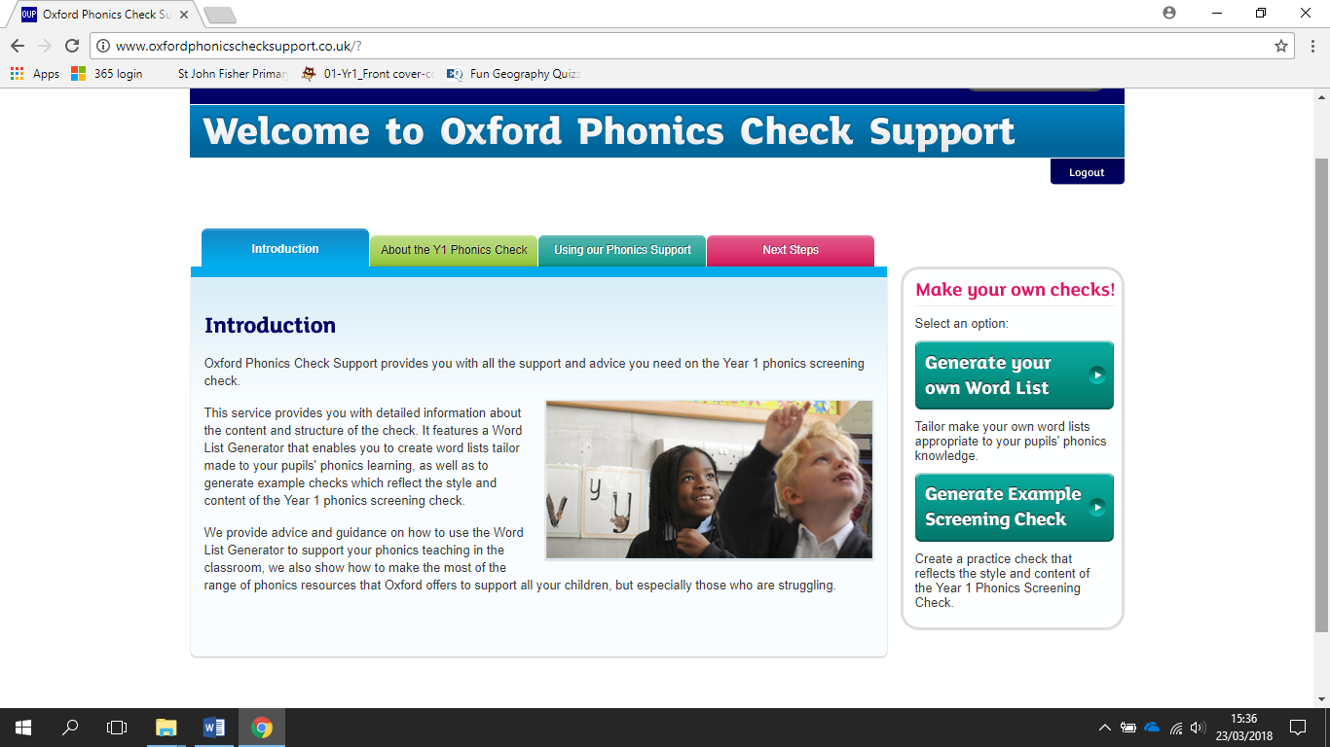

Chose Generate Example Screening Check
It will generate and put it to bottom of your page as a download.
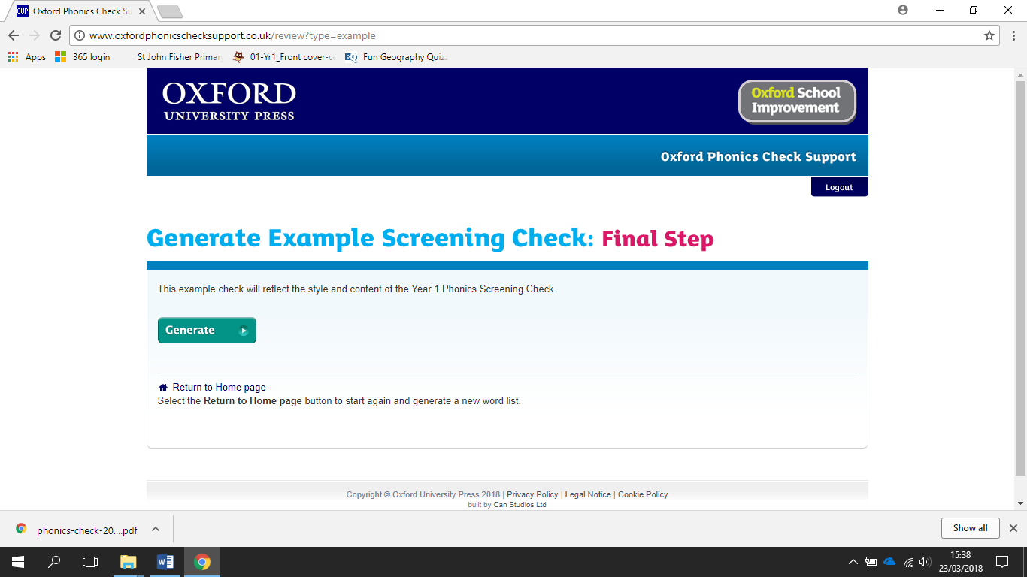

Just open it up. It will look something like this
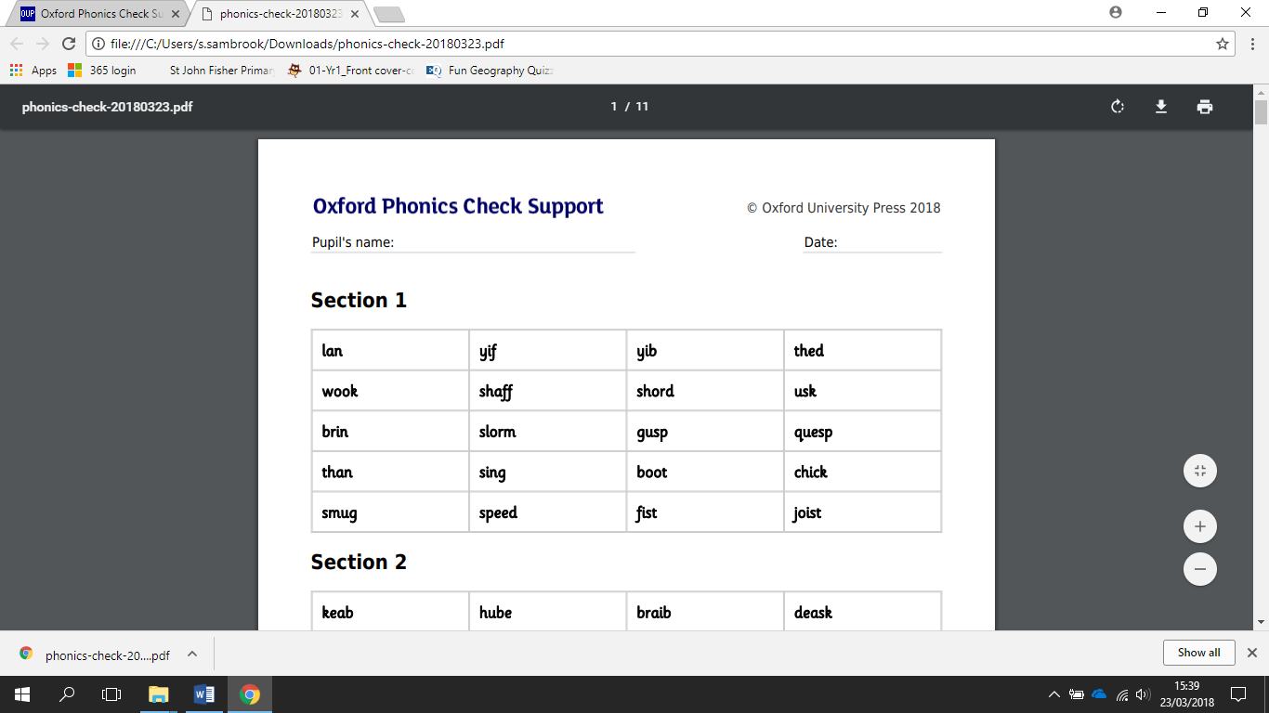

Scroll down and ask your child to read each work by sounding out!

